Explosion-Proof Horn Speaker FEX-350

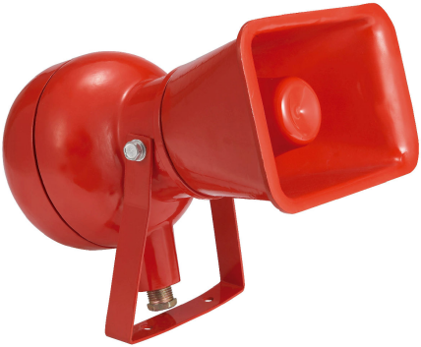
Features:
- Explosion-proof and fireproof PA system, EVAC, paging and music horn speaker.
- Special design for industrial application like oil field, gas field, coal mine and nuclear power station.
- Suitable for explosion-proof, indoor & outdoor and waterproof extremely hostile working environment.
- Working in explosive gas mixture dangerous atmosphere: 0 zone, 1 zone & 2 zone
- Working in explosive gas mixture of IIA, IIB & IIC
- Temperature grade support from T1 to T6
- Built-in 100v/70v line transformer.
- IP65 waterproof and dustproof rate.
- Explosion-proof horn speaker power output 50W @100V.
- Steel enclosure and stainless steel bracket in red.
- Compliant with explosion-proof EXDII CT6.
- Compliant with fire-proof standards

Specification:
Model | FEX-350
Description | Fireproof & Explosion-proof Horn Speaker
Power Output | 50W
Input | AC100V-127V
SPL | 102dB(Rated power /1m)
Frequency Response | 250-8KHz
Explosion-proof Rate | EXDII CT6
IP Rate | IP65
Material | Stainless Steel body in red
Mounting | With U-shaped mounting bracket
Dimension | 255W)×220(D)×200(H)mm
Weight | 6.7kg

Dimension & Frequency Diagram:

